Mathematics Test
Time: 90 minutes

Q1.(10 points) The distance between point $A [1, 2]$ and point $B [x_{B}, y_{B}]$ is 5 (square brackets show $x$ and $y$ coordinates of a point). If $x_{B}=y_{B}$, what are the coordinates of point $B$?

Q2.(10 points) How many times does the graph of the following function cross the $x$ (horizontal) axis:
$$f\left(x\right)=x^{3}-4x^{2}+5$$

Q3.(10 points) Simplify the following expression:
$$\frac{{\left(a^{\frac{1}{3}}\right)}^{9}-\frac{ab^{4}}{b^{2}}}{a^{3}+ab^{2}-2a^{2}b}$$
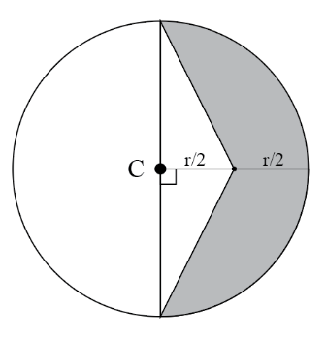
Q4.(20 points) In the following drawing, the point $C$ is the center of a circle with a radius $r$ of 6 cm.

What is the area (in square centimetres) of the shaded (grey) part (round you answer to 2 decimal places)?

Q5.(25 points) A railway company owns 3 types of freight carriages (wagons): animal cage carriage, grain box carriage, and oil tank carriage. A train consisting of 2 animal cage carriages, 5 grain box carriages, and 7 oil tank carriages has a length of 90 meters. A train that has 5 animal cage carriages, 3 grain box carriages, and 4 oil tank carriages is 91 meters long. A train with 7 animal cage carriages, 2 grain box carriages, and one oil tank carriage is 89 meters long.

What is the length of each type of freight carriage (in meters)?

Q6.(25 points) A steel box has to be made with an open top (the top face of the box is missing). The width of the box is equal to the height of the box. Each square centimetre of steel costs 5 cents. Total cost of steel required to make the box is $55. Additionally, four vertical sides of the box (walls) need to be painted outside. Paint per each square centimetre costs 1 cent. Total cost of painting the 4 sides of the box is $8.

What is the length of the box (in centimetres)?

